1. System Modelling
   1. Context modeling

We are divided into three subsystems, Roster management, Pay management and Data Storage.

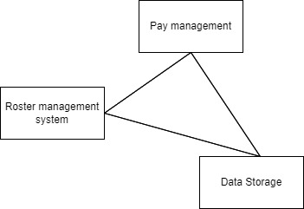

Figure 1: System Context model for the ROSTER Management system

* + 1. Process Perspective

When the employee logs in, the availability working hours are provided, the manager provides the request, and if it matches, the approve for work is provided to complete the system interaction.

* + 1. 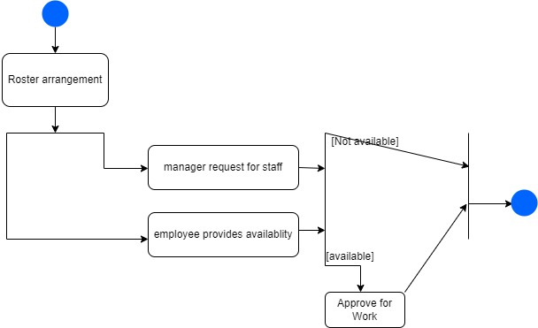

Figure 2: System perspective for the system Interaction Models

* 1. Use Case Diagram

this diagram showing the needs and actions of key stakeholders for the Roster management system.Now we plan three login identities, employee, trainee, manager.

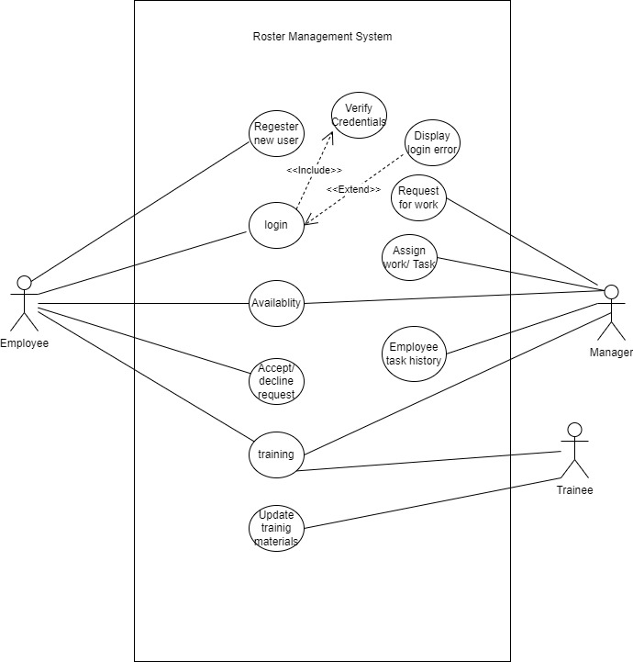

Figure 3: Use case diagram for Employee, Manager and trainee.

* 1. Sequence diagram

The sequence diagram shows employee interactions with objects in chronological order by the Roster management system.

It is divided into several actions: login, sign-up, and interaction with manager.

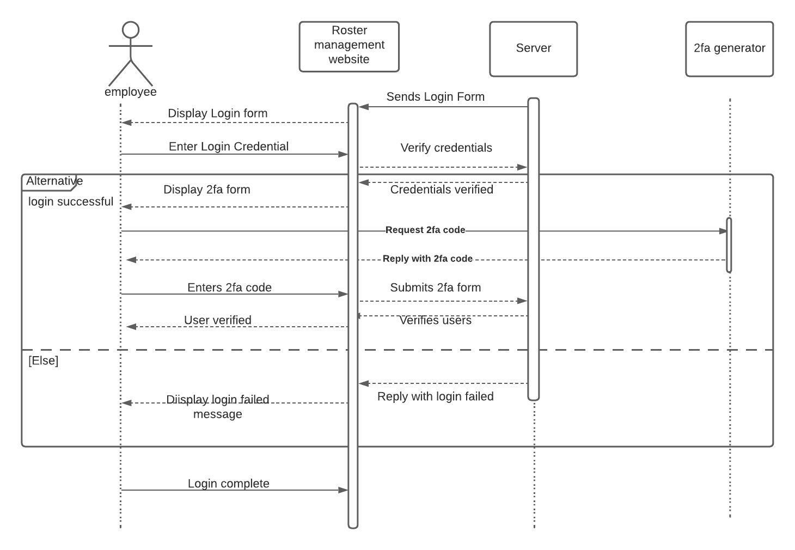

Figure 4: Login Sequence diagram for Employee

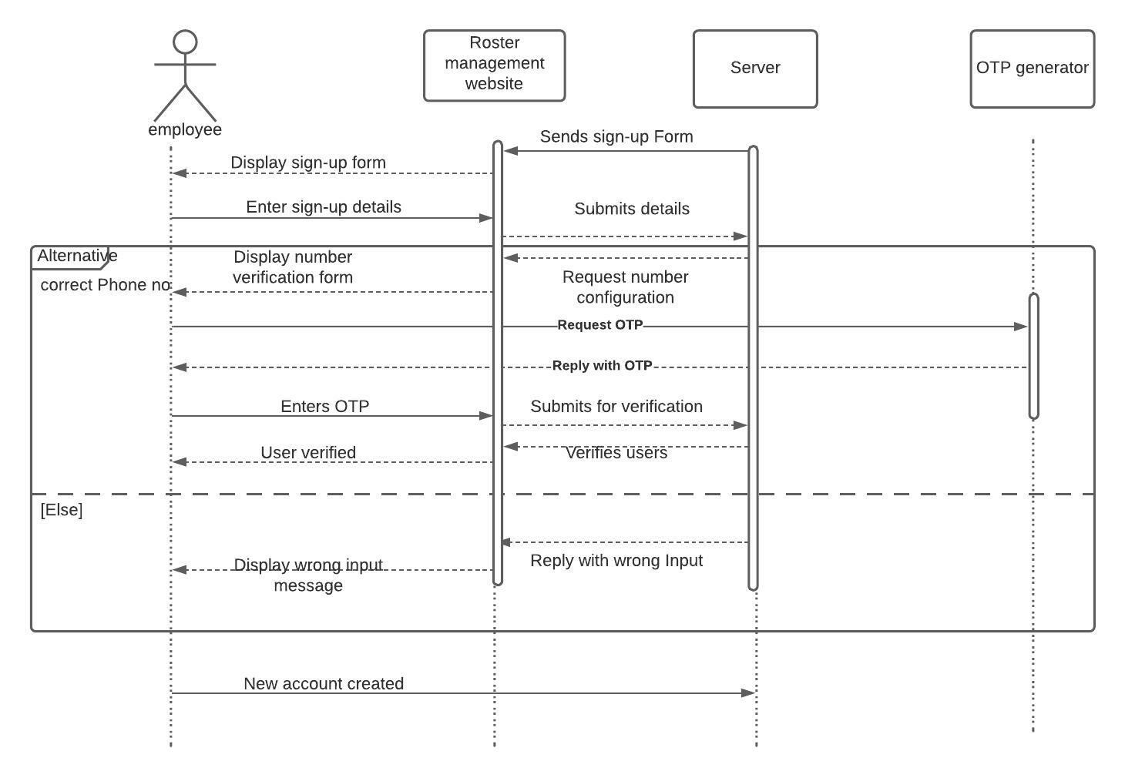

Figure 5: Sign-up Sequence diagram for Employee

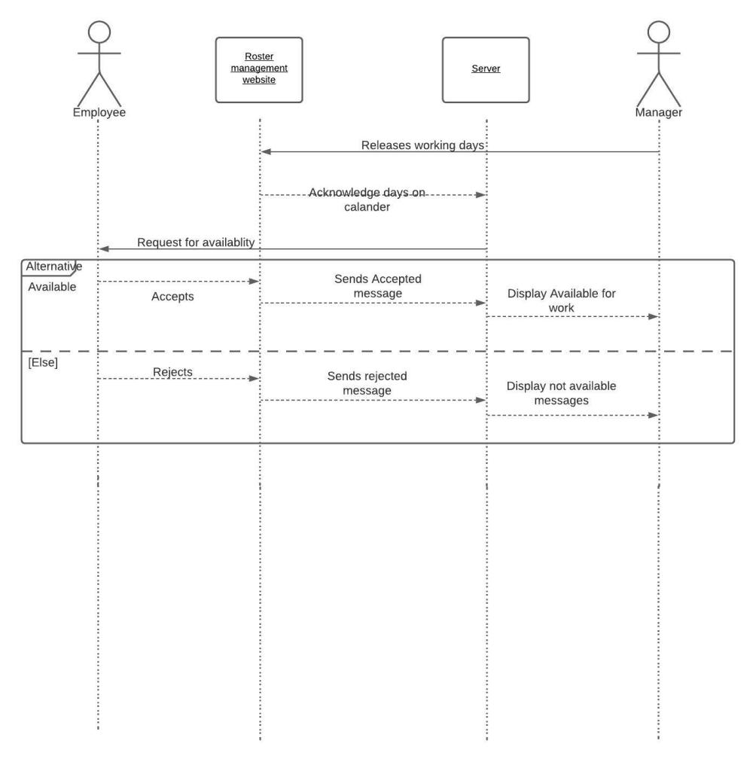

Figure 6 Sequence diagram for roster management

* 1. Class Diagram

UML Classes Diagram shows the relationship between Trainee, employee and Roster Manager when operating Training

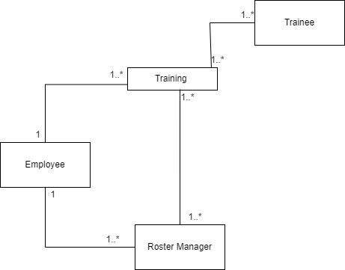

Figure 7 UML Classes Diagram for ROSTER management system.

This diagram represents the name, attributes and Operations of the Classes.

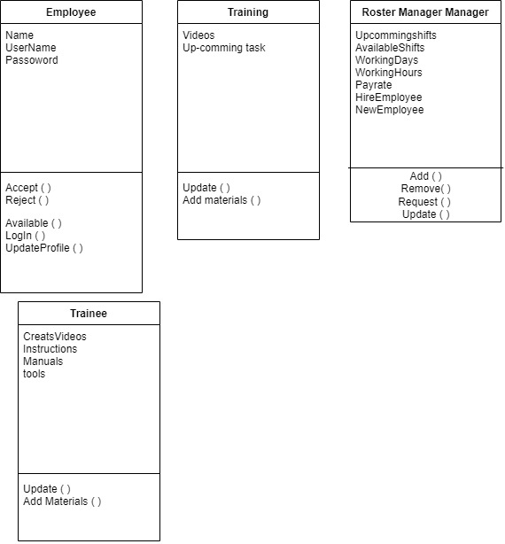

Figure 8 Class Associations for ROSTER Management system

* 1. Behavioral Module
     1. Data Modelling

The Data modeling diagram represents the components and deployment of the system and is a static view of the analysis and design application.

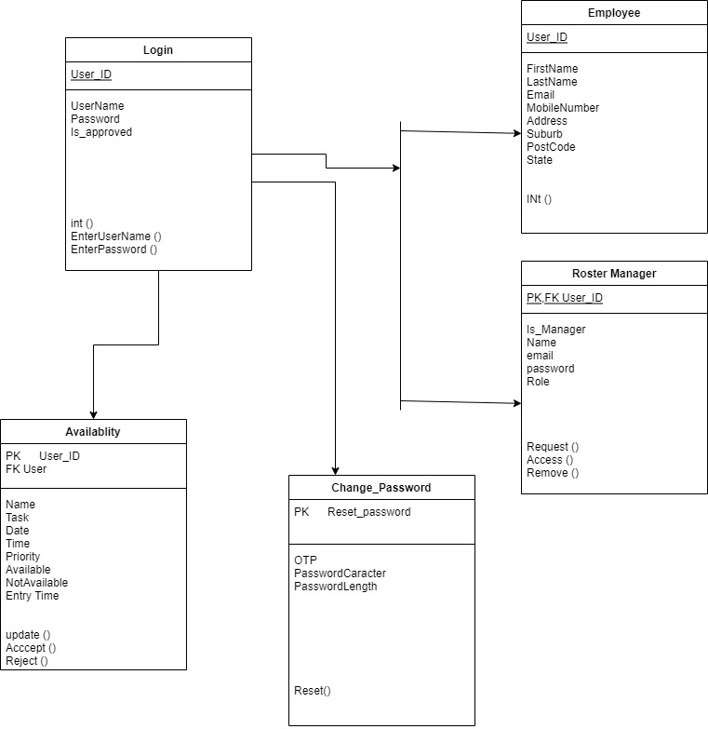

Figure 9 Data modeling diagram for roster management

* + 1. Event-driven Modelling

The Event-driven Behavioral Module diagram represents the activity flow modeling of the roster management system. Introduces the flow of the system, describes parallelism, branching, and concurrent flow of the roster management system.

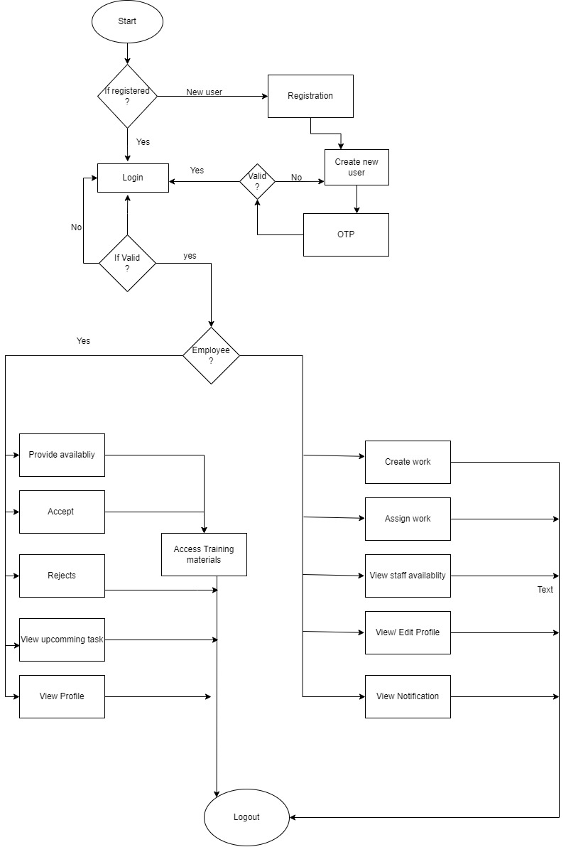

Figure 10 Event-driven Behavioral Module diagram

1. Object Oriented Design
   1. System Context

An association diagram of subsystems represented by objects in the roster management system.

* 1. 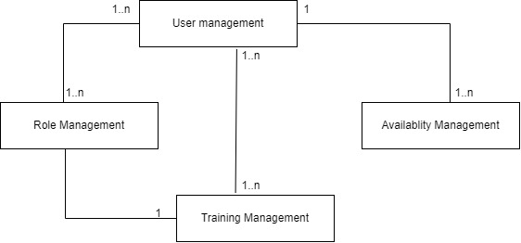

Figure 11 system context object oriented design.

* 1. Use Case

The purpose of the Use Case diagram is to describe the dynamic aspects of the roster management system.

We used four actors, Availability management, Role management, Training management and User management. Below are actors and their use cases

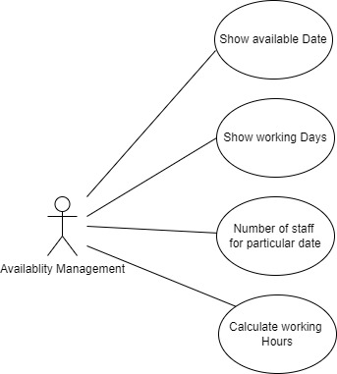

Figure 12 Availability management use case Diagram for ROSTER MANAGEMENT SYSTEM

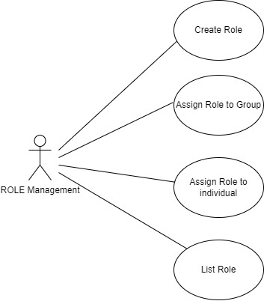

Figure 13 Role management use case Diagram for ROSTER MANAGEMENT SYSTEM.

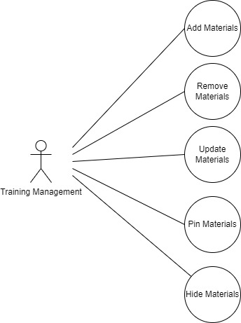

Figure 14 Training management use case Diagram for ROSTER MANAGEMENT SYSTEM

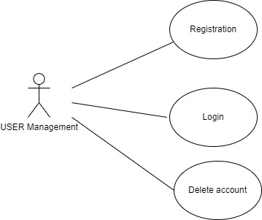

Figure 15 User management use case Diagram for ROSTER MANAGEMENT SYSTEM